**AgencyMedics: Online Service for Health Care**

**Ms. P. SASIKALA1, Ms. N. S. PRIYA DHARSHINI2, Ms. A. K. SWATHI3, Mr. S. SUBESHAMOORTHY4 and Mr. R. RISHIKESAVAN5**

1Department of Computer Science and Engineering, Sri Shakthi Institute of Engineering and Technology Coimbatore, India.

sasikalacse@siet.ac.in

2Department of Computer Science and Engineering, Sri Shakthi Institute of Engineering and Technology Coimbatore, India.

sahadevanpriyadharshini21cse@srishakthi.ac.in

3Department of Computer Science and Engineering, Sri Shakthi Institute of Engineering and Technology Coimbatore, India.

kandasamyswathi21cse@srishakthi.ac.in

4Department of Computer Science and Engineering, Sri Shakthi Institute of Engineering and Technology Coimbatore, India.

sivasamysubeshamoorthy21cse@srishakthi.ac.in

5Department of Computer Science and Engineering, Sri Shakthi Institute of Engineering and Technology Coimbatore, India.

rameshkumarrishikesavan21cse@srishakthi.ac.in

***Abstract***

*****‘AgencyMedics’ is to connect a link among hospitals, pharmacies, patients, doctors, and nurses by uploading their profiles to our website and viewing the accessed profile details of other users. The users who can access the website are Patients, Medical staff like Doctors and Nurses, Hospitals, and Pharmacies. The hospital user is connected to other hospitals, pharmacies, and skilled and verified medical staff like doctors and nurses through the website so that they can save tons of time by getting rid of the middle persons, which helps the hospital to hire staff when they require them, the hospital can also seek help from other hospitals during emergencies, the hospital can also order pharmaceutical drugs from pharmacies******by contacting them through the website by looking into their profile. The pharmacist can view the profiles of hospitals and patients, can view the profiles of hospitals and patients. The patient has access to view all the other user profiles, can view the hospital profile, and pharmacies to buy medicines when they are in need when the pharmaceutical drugs are out of stock in their house or expired, they can also look into the profile of nurses to hire them personally, and they can contact the doctor to treat them in their home when they are sick. The Nurses can only view hospital profile details. Likewise, Doctors can only view hospital profile details.*****

***Keywords:***

***Health Care, Hiring Staffs, Job Offers, Home Care, Hospital, Patient, Pharmacy, Medical Staff.***

1. **INTRODUCTION**

Technological advancements have shown significant growth concern every field of humanity, rapid development that has occurred in smartphones has become a notable factor in achieving our daily tasks. Even the keypad phones have internet access in them. During medical emergencies, Hospital finds it difficult to provide medical services to patients due to a lack of staff in the hospitals and also a lack of staff with proper medical knowledge. It may help unemployed medical workers to find a job that leads them to pursue their careers. Patients who need home care therapy can also hire a medical professional to take care of them by staying by their side. This website connects hospitals, pharmacies, patients, doctors, and nurses. They are the users who can access the website. There are many different websites available while searching on Google. Every day thousands of new websites are uploaded. The number of websites related to health care is more available in the browsers. So through this website, the user can view the profiles of various hospitals, nurses, doctors, patients, and pharmacies by searching them through the search bar. Not every user can view the profiles of every user profile. They can access only the particular user profile according to their role while they log in to our website. The hospital user can view or search for other hospitals, doctors, or nurses' details. The patient can view or search for all user details. The nurse and doctor can only view or search for hospital details. The pharmacist user can view or search for patient and hospital details. This website helps the users by making them save their precious time because there is no middle-person among the users.

1. **LITERATURE REVIEW**

**2.1 E-recruitment in the healthcare industry: The role of organizational brand and website information in attracting job seekers by Parry, E., and Tyson, S. published in the International Journal of Medical Informatics (2014).**

This study explores the role of organizational brand and website information in attracting job seekers in the healthcare industry. It highlights the importance of effective employer branding and the impact of website design and content on attracting qualified medical professionals through online recruitment platforms.

**2.2 E-recruitment and the benefits of organizational websites for healthcare recruitment by Feffer, M., and Sander, M. published in the Journal of Health Organization and Management (2012).**

This paper examines the benefits of organizational websites for healthcare recruitment. It discusses the advantages of online recruitment, such as speed and efficiency, and explores the impact of website design, usability, and information on attracting medical staff through online platforms.

**2.3 Online recruitment of healthcare professionals: A systematic review" by Parry, E., and others published in the Journal of Medical Internet Research (2017).**

This systematic review examines the online recruitment of healthcare professionals. It provides overview of effectiveness, challenges, and ethical considerations for online recruitment platforms. The paper offers insights into the impact of technology on recruitment processes and the potential benefits and drawbacks of online recruitment in the healthcare industry.

**2.4 Online recruiting and applicant tracking systems: An exploratory study of flexibility and outcomes" by Rynes, S. L., and others published in the International Journal of Selection and Assessment (2008).**

This study investigates the uses of online recruiting and applicant tracking systems (ATS) in various industries, including healthcare. It explores the flexibility and outcomes of online recruitment platforms, shedding light on their effectiveness in attracting and selecting medical staff.

**2.5 Exploring online job ads as a source of recruitment data for occupational health research by Choi B, and others published in the Journal of Occupational and Environmental Medicine. (2013).**

This study examines the use of online job advertisements as a source of data for occupational health research. It explores the potential of online job ads for identifying healthcare job trends, skill requirements, and recruitment strategies, offering insights into online medical staff recruitment.

1. **EXISTING METHOD**

Recruiters or hiring medical staffs can log in and access applicant profiles on the user dashboard provided by the recruitment system. A list of applicants may be present on the dashboard, along with brief descriptions of essential characteristics like names, contact information, and application progress. Normally, when a candidate's profile is clicked from the preview, a thorough look with all the pertinent details opens. The candidate's resume, job history, education, qualifications, and any other papers they may have supplied are all examples of what may be included in this. The fitness of an applicant for a specific position can be determined by carefully reviewing this data with recruiters.

One of the other specialized online platforms to recruit healthcare candidates is job boards and career websites, online platforms dedicated to job postings and recruitment. Healthcare organizations can post job openings on these platforms, and medical professionals can search for relevant positions and submit their applications online. Examples of popular job boards and career websites include Indeed, LinkedIn, and specialized healthcare job boards like Health eCareers and PracticeMatch.

Profiles on these websites often have limited space or predefined sections for candidates to showcase their skills, experience, and achievements. It can result in incomplete or insufficient information, making it challenging the employers by making their difficulty in understanding the candidate's qualifications. Many websites heavily rely on self-reported information provided by candidates. While some platforms attempt to verify user profiles, it may not be easy to ensure the accuracy and authenticity of the information given by the user. It challenges employers who need reliable and verified information for their hiring decisions. While these platforms allow candidates to highlight their work experience and technical skills, they may not provide a comprehensive view of a candidate's soft skills, such as communication, teamwork, problem-solving, and leadership abilities. Testing these skills may require additional steps beyond profile viewing, such as interviews or assessments for the candidates by the employer.

1. **PROPOSED METHOD**

**4.1 DESCRIPTION**

'AgencyMedics' website was mainly designed to provide professional medical staff for hospitals. It had also used to find jobs for candidates who have uploaded their profiles to our website. It saves time by avoiding the middle agents. Patients who need home therapy can also hire staff using this platform. The Hospitals can also contact Doctors from other hospitals for emergency needs when there is insufficient staff to provide medical service to the patients. So through our website, the user can view the profiles of various hospitals, nurses, doctors, patients, and pharmacies by searching them through the search bar. Not every user can view the profiles of every user profile. They can access only the particular user profile according to their role while they log in to our website. This website helps the users by making them save their precious time because there is no middle-person among the users. There is also a chance for them to get employed or have an agreement among them by contacting them by looking into their profile on our website. The end users of our product are Patients, Medical staff (Doctors and Nurses), Hospitals, and pharmacies. When the user is logged in or signed in as a patient can access all user profiles by searching them by their names to find them out from the list. Hospital users can access hospitals, nurses, and doctors. Pharmacy users can access hospitals and patients. Nurses can access only the hospitals. Likewise, Doctors can access only the hospitals.

The advantages of the proposed methodology are saving time for the user by avoiding the middle person; the users can update their information; user-friendly access; gives information about medical staff, help medical staff to get employed to pursue their career, and reliable to use.

**4.2 FLOW DIAGRAM**

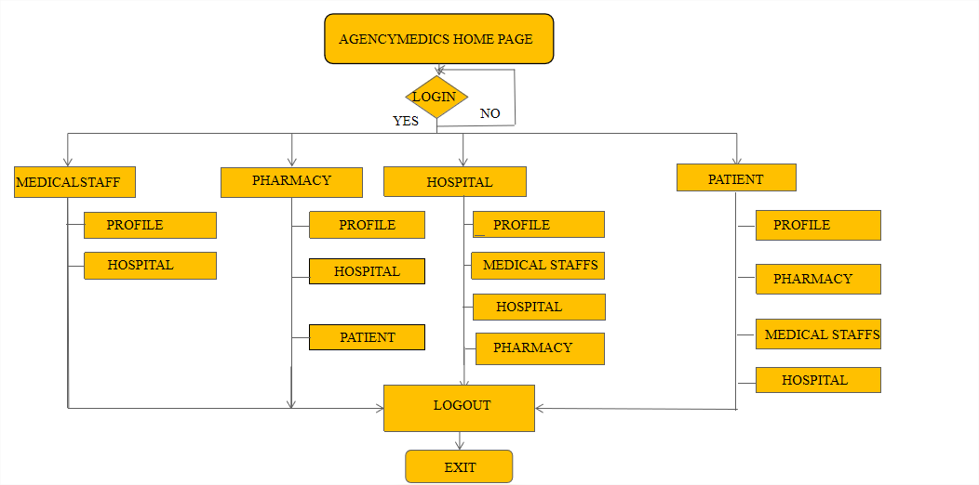

Fig. 1 Flow diagram for the proposed method of how the AgencyMedics website works

Fig. 1 is the flowchart representation of how the proposed method works. The website has many users hospitals, nurses, doctors, patients, and pharmacies. The modules present on the website are the hospital module, nurse module, doctor module, patient module, and pharmacy module. Each module plays a role according to the user. From Fig. 1, it is clear that the user login details, the user are classified based on their user type and access to the module corresponding to it. The hospital as a user can update their profile and view other hospitals' profiles, medical staff like doctors and nurses profiles, and pharmacy profiles. The medical staff user can update their profile and view the hospital's profiles. Pharmacist user can update their pharmacy profile and view the profiles of patients and hospitals. The patients can update their profiles and view all the other user profiles.

**4.3 METHODOLOGY**

The technological methods used to develop the website are Html and CSS for front-end designing, Php is for server-side scripting, and Mysql for data storing in the database. The Collection of web pages is called a website. Php is to connect the database to the website. The required hardware and software for Visual Studio Code are listed below. Run the code using Xampp: Environment for implementation. The front end uses HTML, CSS, and JavaScript, while the back end uses PHP and MySQL. Windows 11 serves as the operating system. RAM exceeds 4 GB.

1. **MODULE DESCRIPTION**

**5.1 Hospital Module**

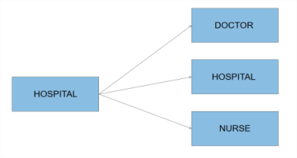

Fig. 2 Hospital Module

The hospital user can view the profiles of Doctors, Nurses, and other hospitals. They can also update their profiles. The hospital can contact doctors or nurses from other hospitals to treat patients in critical situations. They can also call for interviews with doctors and nurses looking for a job.

**5.2 Pharmacy Module**

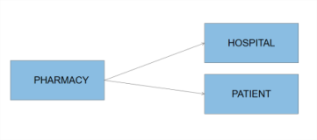

Fig. 3 Pharmacy Module

The pharmacist user can view the profiles of hospitals and patients. They can also update their profiles. The pharmacy can supply pharmaceutical drugs to patients and hospitals when they order by contacting them. The pharmacy can also deliver the ordered items to their address by looking into their details from the website by searching by their name.

**5.3 Nurse Module**

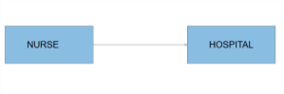

Fig. 4 Nurse Module

The hospital profiles are the only things the nurse user can see. Additionally, they can edit their profile. When nurses are seeking jobs in hospitals, they can get in touch with them and inquire about any staffing updates. They might have the chance to follow their career and land a job in the hospital of their dreams.

**5.4 Patient Module**

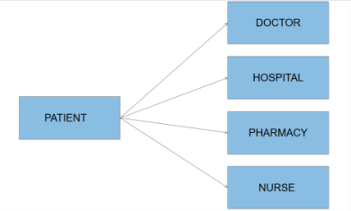

Fig. 5 Patient Module

The patient user can view the profiles of doctors, hospitals, pharmacies, and nurses. They can also update their profiles. Patients who want to get treatment at home can contact the doctors by looking into their profile on the website, but for severe cases, they are advisable to go to hospitals to get the treatment. They can also book appointments in the hospitals by contacting them. The patients who need home nurses can contact the nurses about their requirements by looking into their profiles on the website and appointing them. They can also order medicines from pharmacies.

**5.5 Doctor Module**

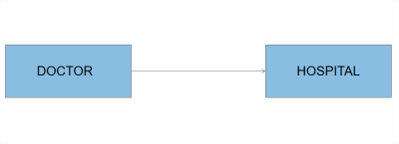

Fig. 6 Doctorl Module

Only the hospital profiles are visible to doctors. Additionally, they may edit their profile. When doctors are seeking work at hospitals, they can get in touch with the facility and inquire about any staff hiring updates. They could have the chance to follow their profession and land a job in the hospital of their dreams.

1. **RESULT AND DISCUSSION**

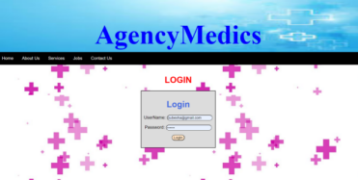

Fig. 7 LogIn Page

The login page connects to the AgencyMedics database, where it can log in only to the signed-in users; if the user has no account on the website, they must sign in to access it. The login page will navigate to the desired page according to the user’s role stored in the database.

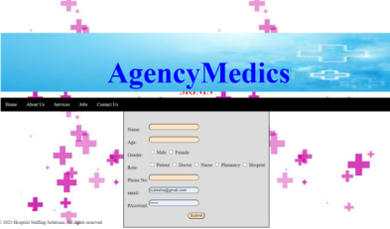

Fig. 8 SignIn Page

The sign-in page is to create an account for the user. User information is stored in the database and connects to the sign-in form.

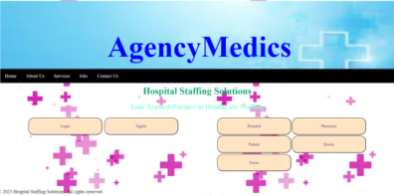

Fig. 9 Home Page

There are five end users, Hospital, Pharmacy, Patient, Nurse, and Doctor. Through the login Page, they assign to their desired pages. The hospital has access to other hospitals, doctors, and nurses. The patient has access to Hospital, Pharmacy, Nurse, and Doctor. Pharmacy users have access to patient details and hospitals. Nurses and Doctors have only access to hospitals.

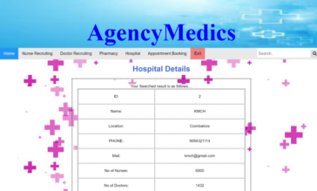

Fig. 10 User Page showing result according to the search

This page shows the collection of hospital information retrieved from the AgencyMedics database and displays it to the user. This page has a search icon to search specific documents from the list.

1. **CONCUSION AND FUTURE SCOPE**

**7.1 CONCLUSION**

The employment procedure has been more effective, accessible, and flexible thanks to online medical staff recruitment, which has completely changed the healthcare sector. Despite its difficulties, internet hiring has more advantages than disadvantages, giving healthcare organizations a tool to find and hire the top medical specialists for their teams. It enables healthcare organizations to interact with competent individuals from diverse geographical regions and gives them access to a broader talent pool. It increases the likelihood of discovering the ideal applicant with the required qualifications. Additionally gave more flexibility and convenience. The recruiting process is more effective by candidates' ease of job searching and application from the comfort of their homes and recruiters' accessibility to applications at any time.

**7.2 FUTURE SCOPE**

The AgencyMedics can be enhanced to include some other functionality in the future like, will provide the opportunity to book medicines through pharmacies nearby when the pharmaceutical drug is out of stock in the hospitals. It will allow the patients to book doctor appointments so that the patients can save time. This application can upgrade to cover more users. This approach is to design as an online platform and will design as an app for iOS, android, windows OS and other popular mobile operating systems.

**REFERENCES**

1. Ahn, T., Ryu, S., & Han, I. (2007). The impact of web quality and playfulness on user acceptance of online retailing. Information & Management, 44(3), 263–275. Bhatti, N., Bouch, A., & Kuchinsky, A. (2000).
2. Brailovsky, C., Chertow, C. M., & MacLeod, S. M. (2002). The contribution of personal attributes to the medical interview. Advances in Health Sciences Education, 7(3), 211-222.
3. Gleich, C., Kolb, B., & Greitemann, B. (2016). A system for automatically evaluating medical staff profiles using job-specific criteria. BMC Medical Education, 16(1), 141.
4. Great candidates fast: Online job application and electronic processing. Public Personnel Management, 31(1), 53–64. Blackman, A. (2006).
5. Karazivan, P., Dumez, V., Flora, L., Pomey, M. P., Del Grande, C., Ghadiri, D. P., ... & Fernandez, N. (2015). The patient-as-partner approach in health care: A conceptual framework for a necessary transition. Academic Medicine, 90(4), 437-441.
6. Lievens, F., & Sackett, P. R. (2017). The validity of interpersonal skills assessment via social media: A review and future directions.102(1), 54-70.
7. N.Esfandiari, M.R.Babavalian, A.M.E. Moghadam , V.K. Tabar, Knowledge discovery in medicine: Current issue and future trend, Expert Syst. Appl. 41 (2014).
8. Collins, Sandra K. "Employee Recruitment." Health Care Manager 26, no. 3 (July 2007): 213–17.
9. Breaugh, James A. "Employee Recruitment." Annual Review of Psychology 64, no. 1 (January 3, 2013): 389–416.
10. Ludlow, R. and Panton, F. (1991) The Essence of Successful Staff Selection , London, Prentice-Hall.